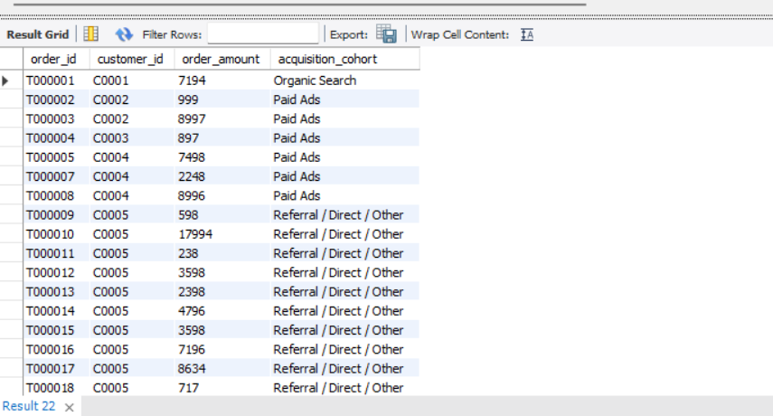
Create a staging view or temporary table for standardized channel cohorts.

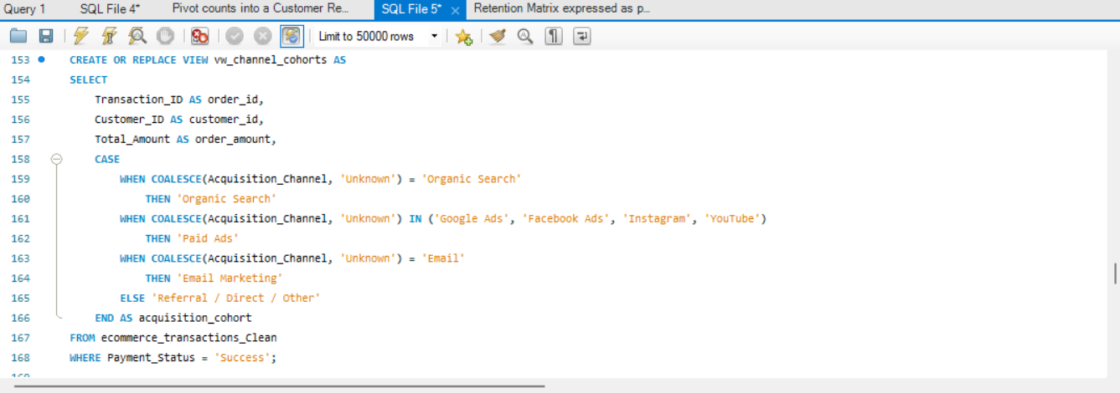
QUERY-;

OUTPUT-;

